# Lab: Arrays

Problems for exercise and homework for the ["JS Fundamentals" Course @ SoftUni.](https://softuni.bg/trainings/4221/programming-fundamentals-with-javascript-september-2023)   
Submit your solutions in the SoftUni judge system at: <https://judge.softuni.org/Contests/1243>

## Sum First and Last Array Elements

Write a function that receives an **array of numbers** and prints the sum of the **first** and **last** element in that array.

### Examples

|  |  |
| --- | --- |
| **Input** | **Output** |
| [20, 30, 40] | 60 |
| [10, 17, 22, 33] | 43 |
| [11, 58, 69] | 80 |

### Hints

* You can access the **last element** in an array by subtracting 1 from **its length**:

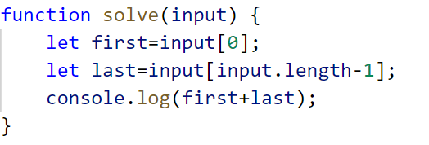

## Day of Week

Write a program, which receives a **number** and prints the corresponding **name** of the **day** of the week (in English).

If the number is **NOT** a valid day, print: **"**Invalid day!**"**.

### Examples

|  |  |
| --- | --- |
| **Input** | **Output** |
| 3 | Wednesday |
| 6 | Saturday |
| 11 | Invalid day! |

### Hints

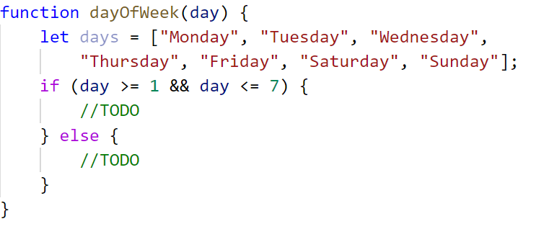

## Reverse an Array of Numbers

Write a program, which receives a number n and an **array** of elements. Your task is to **create** a new array with n numbers from the original array, **reverse** it and print its elements on a single line, space-separated.

### Examples

|  |  |
| --- | --- |
| **Input** | **Output** |
| 3, [10, 20, 30, 40, 50] | 30 20 10 |
| 4, [-1, 20, 99, 5] | 5 99 20 -1 |
| 2, [66, 43, 75, 89, 47] | 43 66 |

### Hints

* Use push() to add elements inside the new array

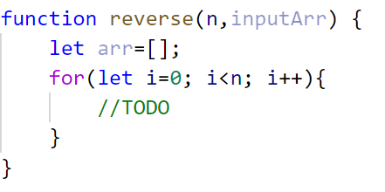

* Use **string interpolation** for the output

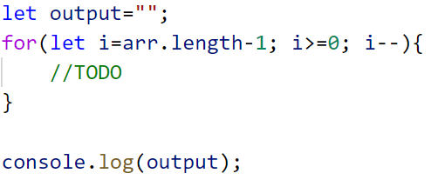

## Reverse In Place

Write a program, which receives an **array of strings**. Your task is to **reverse** the array **without** creating a new array. **Print** the resulting elements on a single line, space-separated.

### Examples

|  |  |  |
| --- | --- | --- |
| **Input** | **Output** | **Comments** |
| ['a', 'b', 'c', 'd', 'e'] | e d c b a | The first element should be **last**, and the last element should be **first**. |
| ['abc', 'def', 'hig', 'klm', 'nop'] | nop klm hig def abc |  |
| ['33', '123', '0', 'dd'] | dd 0 123 33 |  |

### Hints

* Loop to the **half-length** of the array
* Create a function to swap **two elements** inside an array

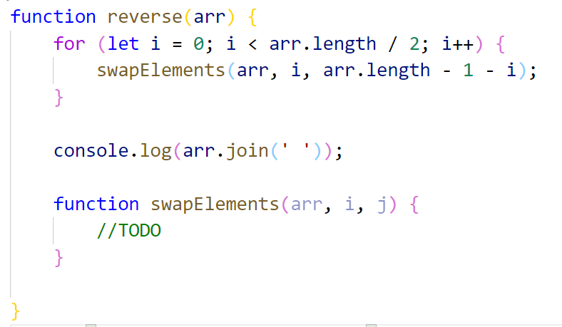

## Sum Even Numbers

Write a program, which receives an **array** ofstrings**,** **parse** them into numbers, and **sum** only the **even** numbers.

### Examples

|  |  |
| --- | --- |
| **Input** | **Output** |
| ['1','2','3','4','5','6'] | 12 |
| ['3','5','7','9'] | 0 |
| ['2','4','6','8','10'] | 30 |

### Hints

* Parse each string to number

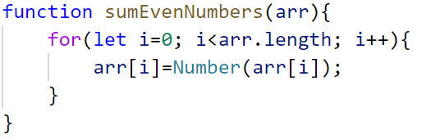

* Create a variable for the sum



* Iterate through all elements in the array with a for-of loop
* Check if the number is **even**

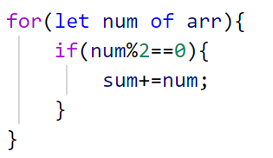

* Print the total sum

## Even and Odd Subtraction

Write a program that calculates the **difference** between the sum of the **even** and the sum of the **odd** numbers in an array.

### Examples

|  |  |  |
| --- | --- | --- |
| **Input** | **Output** | **Comments** |
| [1,2,3,4,5,6] | 3 | 2 + 4 + 6 = 12, 1 + 3 + 5 = 9, 12 - 9 = 3 |
| [3,5,7,9] | -24 |  |
| [2,4,6,8,10] | 30 |  |

### Hints

* Parse each string to number

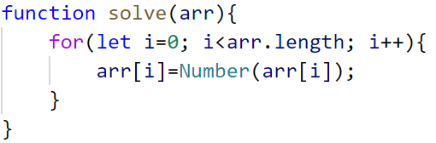

* Create two variables - for **even** and **odd** sum

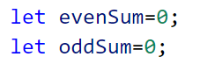

* Iterate through all elements in the array with for-ofloopand check if the number is odd or even

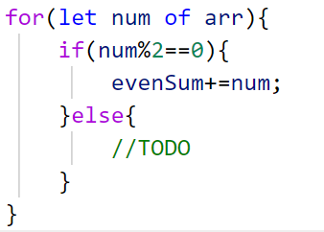

* Print the difference

## Equal Arrays

Write a program, which receives two **string** arrays containing number representations, and prints on the console whether they are **identical**.

Arrays **are identical** if their elements at same indexes are **equal**. If they are identical, find the **sum** of the first array and print the following message:

**`**Arrays are identical. Sum: {sum}**`**

If the arrays are **NOT identical,** find the **first index** where the arrays **differ** and print the following message:

**`**Arrays are not identical. Found difference at {index} index**`**

### Examples

|  |  |
| --- | --- |
| **Input** | **Output** |
| ['10','20','30'], ['10','20','30'] | Arrays are identical. Sum: 60 |
| ['1','2','3','4','5'], ['1','2','4','4','5'] | Arrays are not identical. Found difference at 2 index |
| ['1'], ['10'] | Arrays are not identical. Found difference at 0 index |

### Hints

* First, we receive **two** arrays of strings and parse them.

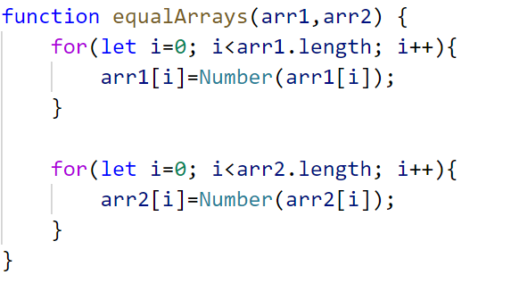

* Iterate through the arrays and **compare all elements**. If the elements are **NOT equal,** print the required message and break the loop.

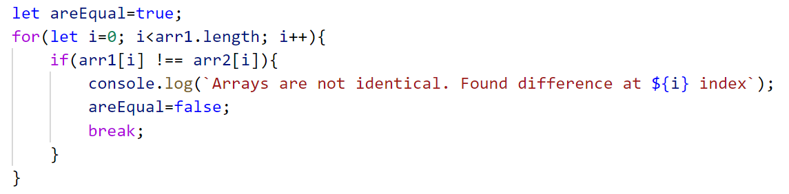

* Think about how to solve the other part of the problem.

## Condense Array to Number

Write a program, which receives an array of numbers, and **condenses** them by **summing** adjacent couples of elements until a **single number** is obtained.

### Examples

For example, if we have 3 elements [2, 10, 3], we sum the first two and the second two elements and obtain **{2+10, 10+3} = {12, 13}**, then we sum again all adjacent elements and obtain **{12+13} = {25}.**

|  |  |  |
| --- | --- | --- |
| **Input** | **Output** | **Comments** |
| [2,10,3] | 25 | 2 10 3 🡪 2+10 10+3 🡪 12 13 🡪 12 + 13 🡪 25 |
| [5,0,4,1,2] | 35 | 5 0 4 1 2 🡪 5+0 0+4 4+1 1+2 🡪 5 4 5 3 🡪 5+4 4+5 5+3 🡪 9 9 8 🡪 9+9 9+8 🡪 18 17 🡪 18+17 🡪 35 |
| [1] | 1 | 1 is already condensed to number |

### Hints

While we have more than one element in the array nums[], repeat the following:

* Allocate a new array condensed[] of size nums.Length-1.
* Sum the numbers from nums[] to condensed[]:
  + condensed[i] = nums[i] + nums[i+1]
* nums[] = condensed[]

The process is illustrated below:

